|  |  |  |  |  |  |  |  |  |  |  |  |  |
| --- | --- | --- | --- | --- | --- | --- | --- | --- | --- | --- | --- | --- |
| Name Song : Manyar Sewu Number of instrument : 3 | | | | | | | | | |  |  |  |
| Number of Notation : 30 Name of instrument : Demung | | | | | | | | | | |  |  |
| Name Song : Manyar Sew Number of instrument : 3 | | | | | | | | | |  |  |  |
| Number of Notation : 30 Name of instrument : Demung | | | | | | | | | | |  |  |
| Tempo : 2 second Saron | | | | | | | | | | |  |  |
| Type : Synthetic Peking | | | | | | | | | | |  |  |
|  |  |  |  |  |  |  |  |  |  |  |  |  |
|  |  | Estimated Notation | | | | | |  |  |  |  |  |
| Notation | Original | 1 | 2 | 3 | 5 | 6 |  | Correct | Replace | Lost | Insert | Perform |
| Number | Notation | 7 | (C) | (R) | (L) | (I) | (P) |
| 1 |  |  |  |  |  |  |  |  |  |  |  | 100% |
| 2 | 4 |  | 4 |  |  |  |  | 4 |  |  |  | 100% |
| 3 | 7 |  |  | 7 |  |  |  | 7 |  |  |  | 100% |
| 5 | 7 |  |  |  | 7 |  |  | 7 |  |  |  | 100% |
| 6 | 8 |  |  |  |  | 8 |  | 8 |  |  |  | 100% |
| 7 | 4 |  |  |  |  |  | 4 | 4 |  |  |  | 100% |
| sum | 30 | 0 | 4 | 7 | 7 | 8 | 4 | 30 | 0 | 0 | 0 | 100% |
|  |  |  |  |  |  |  |  |  | | | | |
| Performance Evaluation | | | | |  |  |  |
|  |  |  |  |  |  |  |  |
|  |  |  |  |  |  |  |  |

Page 1

Original Waveform

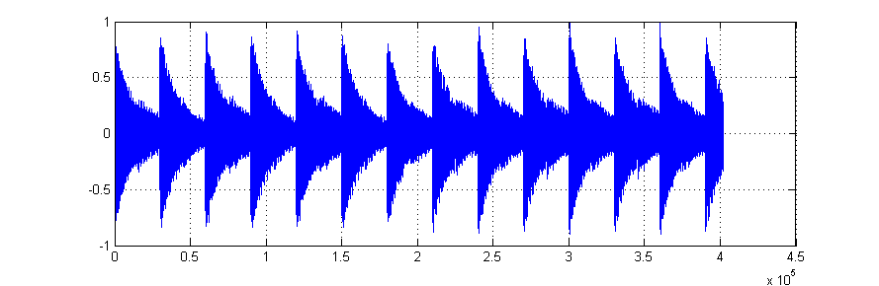

Original gamelan notation

5 3 5 3 5 3 6 5 6 5 6 5 6 5

Estimated waveform of Saron based on the template

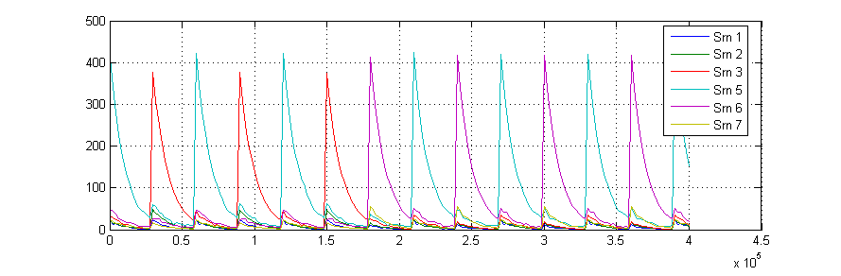

Estimated notation of Saron

5 3 5 3 5 3 6 5 6 5 6 5 6 5

Page 2

Original Waveform

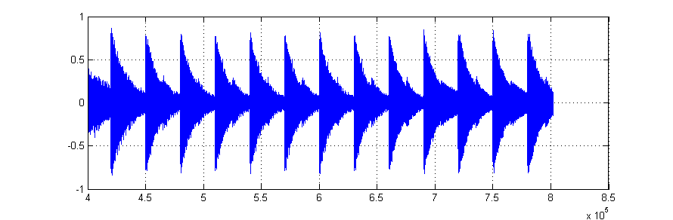

Original gamelan notation

3 2 3 2 3 2 3 2 7 6 7 6 7

Estimated waveform of Saron based on the template

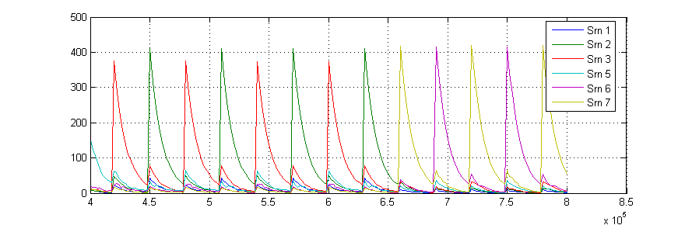

Estimated notation of Saron

3 2 3 2 3 2 3 2 7 6 7 6 7

Page 3

Original Waveform

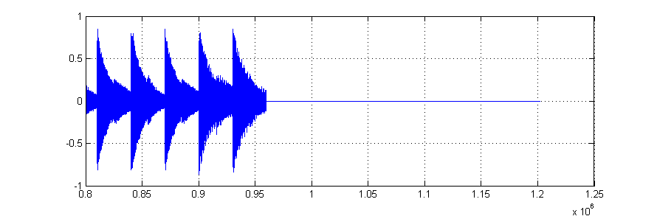

Original gamelan notation

6 7 6 5 3

Estimated waveform of Saron based on the template

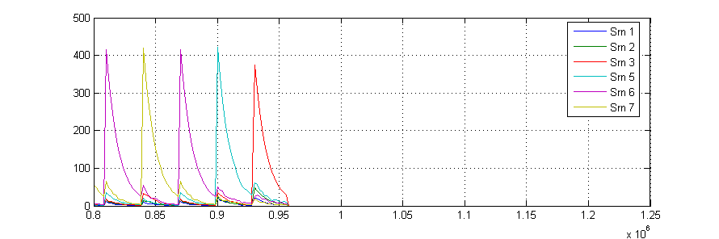

Estimated notation of Saron

6 7 6 5 3